Greater Richmond, Virginia Labor Shed
Businesses in the Richmond, Virginia metro area draw labor from 45 counties in central Virginia – an area with nearly 2.5 million population and a workforce of over 1.2 million.
The primary labor shed is the 17 counties in the Richmond MSA, which has 1.3 million population and a workforce of 695,000. The secondary labor shed, where at least 500 residents per county work in the Richmond MSA. includes 28 counties with a population of nearly 1.2 million and a workforce of 513,000. The region’s population has increased by 9 percent since 2010, adding 19,900 additional residents annually.
Area | Population 2020 | Civilian Labor Force  2022 Q2
Primary Labor Shed (17 counties) | 1,282,067 | 694,963
Secondary Labor Shed (28 counties) | 1,175,076 | 512,672
Total Labor Shed (45 counties) | 2,457,143 | 1,207,635
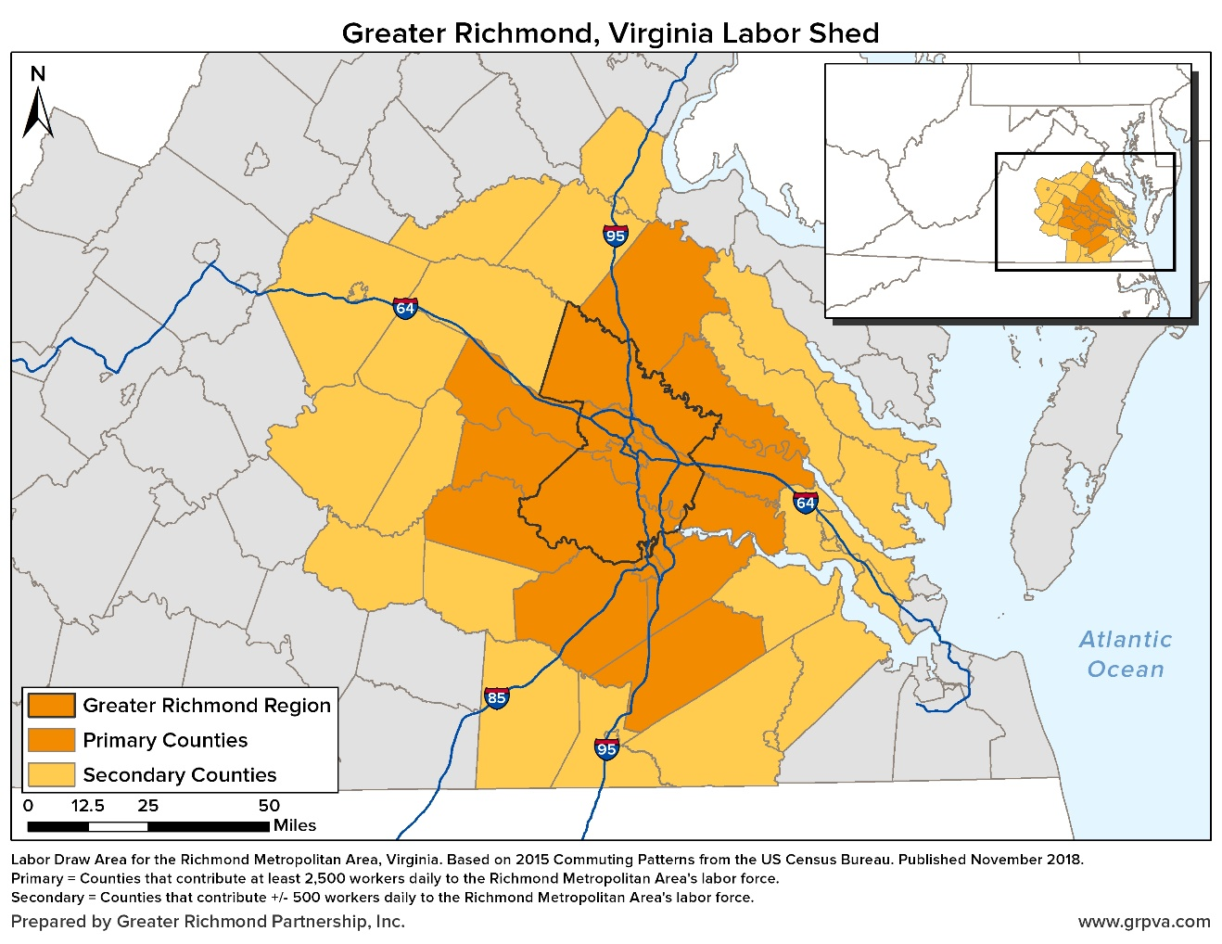

Updated January 2023

